BRIEF HISTORY OF KENTUCKY 1700 - 1783

It is important to know some of the history of Kentucky in order to understand why James Whitehouse came to Kentucky, what people he may have come in contact with and what he faced when he arrived.

The early settlers of Virginia were English but by 1700 large waves of immigrants began to arrive in the ports of Pennsylvania, Maryland and Virginia. These immigrants came from Ireland, Scotland, and various sections of Europe. Some came as indentured servants and others paid their own way. They came hoping to escape wars in Europe, religious persecution and to have a chance for a more prosperous life. They wanted to own their own land. Most of the good land near the eastern shores of the colonies was taken and the immigrants pushed further west into the areas near present day Pittsburgh, Pennsylvania, west into what is now West Virginia and south into the Carolinas. Cut off from Virginia and the Carolinas by the Appalachian Mountains, Kentucky remained uninhabited. The land was called Kaintuckee, Caintuckee or Cantuckey by the Indians, meaning cane land or meadowland. The Indians thought of Kentucky as the Middle Ground, the Breathing Land and the Sacred Soil. Indians did not live in Kentucky, but they did use it as their hunting ground. The Cherokees came from the south, the Shawnees, the Wyandots and other tribes from the north and the Iroquois from the west. Kentucky contained hardwood trees, wild crab apple trees, plains of lush grasses, wild pea vines, wild sugar cane, abundant streams and multiple salt licks (natural deposits of salt or salt streams). The natural salt licks and grasses attracted large herds of wild game including buffalo, elk, deer and bear, flocks of birds such as wild turkeys, and multiple kinds of small game. It was a hunter’s paradise for the Indians who came from the north and the south.

In 1750 Dr. Thomas Walker led three fellow explorers on a surveying expedition for the Loyal Land Company of Virginia entering Kentucky through the Cumberland Gap. To establish a claim they erected an 8 by 12 foot cabin in April 1750. It was the first structure built by a white man in Kentucky. Dr. Walker kept a daily journal of what he observed as he traveled across Kentucky. His journal was later used by George Rogers Clark and others when they arrived in Kentucky. Nothing came of Dr. Walker’s expedition and historically it has been neglected for two reasons. 1) Walker took a path that led through rugged terrain and thickly tangled woods and missed the beautiful plains of rolling bluegrass. As a result, his reports to the land company were unfavorable. 2) Kentucky was disputed land, claimed by England, France, the Iroquois to the west, the Shawnee to the north and the Cherokee to the south.

Between 1754 and 1763 the French and Indian War raged between the British Colonies and New France. It was fought primarily along the frontier from Virginia to Nova Scotia. The French who were greatly outnumbered made heavy use of the Indians. When the war ended in 1763, France relinquished all rights to the land east of the Mississippi River including Canada to the British. England now had a greater claim to Kentucky and the Ohio Territory. In 1763, after France ceded its rights to England, a British royal proclamation forbade any settlement west of the Appalachian Mountains. In defiance of this order, a few settlers began to trickle into Kentucky.

In 1764 Henry Skaggs and his brothers, Irish immigrants, led an expedition from their home in Virginia through the Cumberland Gap into Kentucky. They were known as Long Hunters, famous in Kentucky history, who left home and family on hunting trips lasting as long as two years. In Kentucky they would build a shelter and a storage structure near a stream for the pelts they collected. They would venture out on short hunting trips, collect their game, bring it back to the storage area, skin the game, clean the pelts and store them before venturing out again. When they collected enough pelts, they would bundle them into bales and take them home to Virginia to sell. Then they would leave home and family for another long hunting trip. News of their trips reached Daniel Boone who had settled in the Yadkin Valley of North Carolina in 1762. In the fall of 1767 Daniel reached Kentucky with his brother Squire on a long hunt. The Skaggs brothers and the Boones would later encounter each other on their long hunts to Kentucky and become friends.

In 1771 Simon Kenton was living with his parents in the Bull Run Mountain section of Fauquier County. The Kentons are not shown on any tax records so they probably rented their land. While Kenton’s brothers attended school, Simon preferred to roam the woods and learn the ways of the wilderness. He disliked work and avoided it by leaving his chores at every opportunity. He never learned to read and write but did learn while in Kentucky to sign his name in a mechanical way. At the age of 15 he fell in love with a neighboring girl, only to see her marry an older man. Simon appeared at their wedding and attempted to thrash the man, but was given a thorough beating. Shortly after he turned 16, Simon decided to try again while on an errand to the man’s house. Losing again, Simon lay passive and began to edge toward a small sapling tree. After luring his opponent to follow, Simon grabbed his opponent’s hair and tied it to the tree so that he could not get away. Simon’s rage took over and he beat the man unconscious. After untying the man’s hair, Simon tried to revive him but could not. Thinking the man was dead, Simon fled into the forest. He had no gun, provisions, money, hat, shoes or clothes except what he wore. He ventured west, sometimes asking for food but mostly living off the land. At one point he met a man named Butler and pretended to be a relative. Butler welcomed him and gave him a job. Simon stayed long enough to earn a gun before resuming his journey. Simon kept the name Butler and for years was known as Simon Butler. Meeting up with two men, Simon traveled with them to Kentucky. There he learned the land and became skilled as a scout.

In 1772, 20 year old George Rogers Clark, a surveyor, entered Kentucky for the first time by traveling down the Ohio River from Pittsburgh. In that same year Virginia created Fincastle County whose boundary extended to the Mississippi River and included Kentucky. In 1773 Daniel Boone, accompanied by his family and a group of about 50 people, attempted to establish the first settlement in Kentucky. Attacked by Indians, Boone’s son and another young man were killed. Boone and the settlers abandoned their attempt and returned home. In 1774 James Harrod was ordered by the Virginia governor to survey land in Kentucky that could be given as bounty land to the men who had fought in the French and Indian War. Harrod and his men built the first settlement in Kentucky at Fort Harrod (now Harrodsburg in Mercer County). The settlers were forced to abandon this settlement due to Indian attacks. The attacks on settlers such as the groups led by Daniel Boone and James Harrod led to Lord Dunmore’s War. Lord Dunmore was John Murray, 4th Earl of Dunmore and Governor of Virginia. In October 1774 Virginia achieved victory in the war at the Battle of Point Pleasant which led the Indians to give up their right to hunt south of the Ohio River. The Iroquois had previously ceded their claim in 1768. In 1775 James Harrod and his men returned and rebuilt Fort Harrod to include a strong stockade fence around their cabins for protection in case of future attacks.

In 1775 Richard Henderson of North Carolina hired Daniel Boone to organize a group of men to cut a trail through the Cumberland Gap wide enough for wagons carrying settlers to travel to Kentucky. This trail became known as the Wilderness Road. Earlier, Henderson had formed the Transylvania Land Company with the idea of forming an independent colony of Transylvania in Kentucky. Deciding that the Cherokee Indians had the best claim to Kentucky, he paid the Indians for their rights to the land between the Ohio and Cumberland Rivers with merchandise valued at around $10,000. This land included most of Kentucky. Daniel Boone was recruited by Henderson to lead a group of settlers into Kentucky and form a settlement. Boone’s wife Rebecca and daughter, Jemima, became the first white women to settle in Kentucky. Boone’s Fort or Boonesborough became the second Kentucky settlement. In 1775 Benjamin Logan started the third settlement in Kentucky. Logan named his fort, St. Asaph.

In 1776 the Second Continental Congress of the United States declared their independence from the British Empire and the Revolutionary War began. George Rogers Clark, who opposed the Transylvania Company, and John Gabriel Jones ,representing the Kentucky settlers, traveled to Virginia and asked for support in forming a Kentucky militia to protect the western frontier. Clark arrived after the General Assembly had adjourned but met privately with Governor Patrick Henry and his Executive Council including Thomas Jefferson who promised to help. Governor Henry also promised Clark that he would advocate a law to give generous land grants to men who served under him during the war. Clark and Jones were refused seats when the Assembly again convened, but the Assembly did create Kentucky County from Fincastle County in December 1776 with its own government and declared the Transylvania Company illegal. Clark was commissioned a major and became the effective head of Kentucky’s militia. Benjamin Logan, James Harrod and Daniel Boone were among the captains appointed. Clark sent representatives to Virginia to recruit men to fight on the western frontier, but, faced with recruiters from the Continental Army under George Washington, the Virginia Line (state army) and the Navy (marines), he was never able to raise the total number of men authorized by Virginia for his command. In 1776 the total population of Kentucky was about 200.

In March 1777, when the first formal muster of troops was held, the total number of men in the Kentucky militia was probably no more than 140 men. That year the Indians, incited by the British, launched attacks against the three Kentucky settlements. Running low on food and ammunition, Benjamin Logan slipped out of the St. Asaph fort during the night and managed to evade the Indians surrounding it. Traveling as fast as possible, he made his way to Virginia to ask for help. Meeting with a group of Virginia soldiers, Logan was able to obtain gunpowder and a promise of help. 100 Virginians arrived later and were able to drive the Indians from the settlements. In 1778 the longest siege in United States frontier history occurred at Fort Boonesborough. Boonesborough was later abandoned as a settlement but the town of Lexington sprang up nearby.

In May of 1779 Virginia passed a series of laws which applied to the western frontier including Kentucky. The first Act declared that at the war’s end all soldiers, sailors and marines should be entitled to 100 acres of any unappropriated land in the Commonwealth. Officers were entitled to a grant of land equal to what an officer of the same rank serving in Virginia proper during the war would receive. The law further stated: “every soldier who enlisted under George Rogers Clark, and continued therein until the taking of several posts in the Illinois country, shall at the end of the war be entitled to a grant of 200 acres of any unappropriated lands within this Commonwealth on the terms herein before declared”. A commission from the Virginia Land Office was sent to Kentucky to settle any disputes over land claimed prior to 1779 and to set the foundation for acquiring bounty land due to war service.

Large numbers of men attracted by the abundance of good land in Kentucky, the sparseness of its population and the chance to get free land, began to arrive in Kentucky. Simon Kenton made it a habit to greet and get to know most of the settlers who came to Kentucky. He warned them of the dangers of Indian attacks, led them to safety, and assisted them in finding land and getting settled. In May of 1780, Simon saw the signs of a fire with smoke billowing upward. Knowing that the Indians would also spot the smoke, he edged toward the camp and saw eight men with their guns lying to the side and their canoe still partially in the water. He approached them, showed them how to build a fire with no smoke, advised them to hide their canoe and told them to always keep their guns close to their body. He noticed that one of the men looked vaguely familiar and approached him. As the man started to talk, Simon realized that he was his brother John from Fauquier County. John told him that the man Simon thought he had killed was very much alive. At this time Simon took back his original name of Simon Kenton and was no longer known as Simon Butler. By 1781 the settlements were becoming substantial villages and some like Harrodsburg, Danville, Stanford and Lexington were becoming small cities. The population had grown over a five year period from 200 in 1776 to many thousands. The population of Harrodsburg exceeded twenty-five hundred. On October 19 1781, Lord Cornwallis surrendered his British troops to American forces at Yorktown, Virginia. The Revolutionary War was over east of the Appalachian Mountains.

The first records of James Whitehouse in Kentucky are for the year 1782. James may have arrived much earlier, with the large influx of men who arrived in 1780 and 1781. Since Simon Kenton is reported as meeting most of the settlers and men who arrived in Kentucky during this time, it is very possible that the two met when James arrived in Kentucky. Certainly, as a neighbor of the Kentons, he would have known John Kenton who arrived in 1780. Since the war east of the Appalachian Mountains was over after the surrender of Cornwallis, it was safe for men to leave their wives and children at home while they ventured to Kentucky in search of land. Testimony given in a court case filed in the Mercer County Court May 1803 is the first proof that James Whitehouse was in Kentucky in early 1782. Michael Gash Jr. charged James Whitehouse with trespass and demanded $150 in damages. James was taken into custody and released without bail. The case was not heard till March 1805. An excerpt from the testimony of John McGinnis states: “sometime early in the year of 1782 as well as this Deponent recollects the Defendant brought 2 beds the property of Michael Gash to the home of this Deponent and requested him to take care of them until he came for them & the said Defendant gave the Deponant a particular charge to let no person have said beds either by the word of mouth or by Wrighting even Governor Garrard until he came for them himself.” When McGinnis was asked who took the beds from his house, he replied that the plantiff and the defendant both came together and took them away about five or six days later. Judgment in the case was for James Whitehouse.

Although the war in the east was over, the war on the western frontier continued. On 1 Nov 1780 Kentucky County was divided to form three counties: Fayette, Jefferson and Lincoln. Each county had its own militia composed of several different companies. Each company was composed of about 40 men. Men in the militia were not in the regular army. They were stand-by troops who were required to be available in case they were needed. Each man had a gun and a supply of powder and lead. Private James Whitehouse was in the Lincoln County Militia led by Col. Benjamin Logan. His company of 29 men was commanded by Captain John Gordon and Lieutenant Isaac Hoglan. Another company in the Lincoln County Militia was commanded by Captain Simon Kenton. Being in the same county militia and living in the same area is another indication that James Whitehouse and Kenton probably knew each other in Kentucky. James was living in the same area where he, his wife Sarah and their children, would later settle. Mercer County, where James and Sarah Whitehouse later lived, was formed from a section of Lincoln County in 1785.

The British concentrated their efforts on General Clark and the western frontier after Cornwallis surrendered and planned to launch an attack into Kentucky in August of 1782 with the help of the Indians. The Indians were impatient and went on the warpath. 25 Wyandots crossed the Ohio and surprised John Stroke’s Station, killing two men on 1 March 1782. Venturing further into Kentucky they crossed the Kentucky River and struck Estill’s Station in Lincoln County. In response, several of the companies in the Lincoln County Militia were called to duty. Captain Estill’s company pursued the Indians and caught up with them at Hinkston’s Creek where a battle ensued. Captain Estill and five of his men were killed. Ensign Cook’s company was assigned to guard the frontier of Lincoln County. Captain Barnett’s company and Captain Gordon’s company in which Private James Whitehouse served were assigned to duty at the Falls of the Ohio. Captain Gordon and Lieutenant Hoglan were both killed leaving Ensign Stafford in charge of the company James Whitehouse was in. Men in the militia were not paid unless their company was activated in time of need. With the two leading officers killed, the payroll for James’ company was filled out by Ensign Stafford. While most of the pay records of Virginians who served in the Revolutionary War were destroyed in the War of 1812, when the British burned Washington, the pay records of the men who served under George Rogers Clark on the western frontier were not. The Payroll filled out by Ensign Stafford can be found in the book *George Rogers Clark and His Men Military Records, 1778 – 1784* compiled by Margery Heberling Harding. The payroll shows that Captain Gordon’s company was activated on 15 March 1782 and released from duty on 15 April 1782. Private James Whitehouse was paid 2 pounds, 2 shillings 8 pence for his service.

In August the British went ahead with their planned attack on the settlers of Kentucky by attacking Bryant’s Station. Two of the settlers, realizing that they could not hold out indefinitely at the station, managed to escape and go for help. Daniel Boone was one of the first to arrive with his militia. The British retreated across the Licking River at Blue Licks. Without waiting for more militia groups to arrive and against the advice of Boone, the Americans crossed the Licking River in pursuit. The battle was an overwhelming victory for the British and Indians but marked the last major incursion of Indians into the state. General Clark gathered a force to cross the Ohio and make a final push against the Indians but the force was involved in only minor skirmishes. Clark disbanded his forces and resigned his commission in the fall of 1782.

The men who came to Kentucky by themselves began to make plans to return to Virginia for their families. Simon Kenton recruited men to settle with him on his land at Quick’s Run in Lincoln County. This area became Mercer County in 1785 and Boyle County in 1842. That winter and spring Kenton and his recruits put up several cabins, cleared land and planted corn and flax. Kenton planned to return to Fauquier County in 1783 to persuade his family to move to Kentucky. Whether James Whitehouse joined Simon Kenton in Kentucky or later in Virginia isn’t known. Records show that the men who fought under George Rogers Clark were now able to apply for the 200 acres of land that was promised them in the Land Act of 1779. James Whitehouse filed his claim for 200 acres on the Ohio River in Fayette County on 17 Dec 1782. A few weeks later between 2 Jan and 11 Jan 1783 Simon Kenton filed for 4 parcels of land near the claim of James Whitehouse. In early 1783 news finally reached the frontier that the British and Americans were nearing an agreement to officially end the war. Sometime in the spring or summer of 1783, James returned to Virginia for his wife Sarah and their three children. Simon Kenton returned to Virginia in June of 1783. Kenton was able to convince his parents, several of his siblings, and several neighboring families to join him on his return to Kentucky. Several additional families agree to follow in the spring. Kenton promised each member of his family that he would reward them with no less than 250 acres of land and he promised neighboring families 100 acres of land. The Treaty of Paris was signed on 3 Sep 1783 officially ending the Revolutionary War. In the treaty the British Empire recognized the sovereignty of the United States of America.

The Kenton migration began on the 16th of September 1783. They traveled across the mountains to New Store (now Elizabeth, Pa.) where they ordered a flat boat for their trip down the Ohio. On 16 Oct Simon’s father, Mark Kenton, died. They carried his body two miles up the river and buried him. The flat-bottomed, rectangular boat was 120 feet long. One end contained stock pens for the horses and cattle and the other end contained a multi-room cabin with quarters for the settlers and a fireplace for cooking. The boat was well stocked with corn, salt, flour and meat which they had salted and packed in large barrels. Whenever they stopped the men would chop wood and Simon would hunt. The boat was navigated down the Ohio River by four of the men wielding long poles.

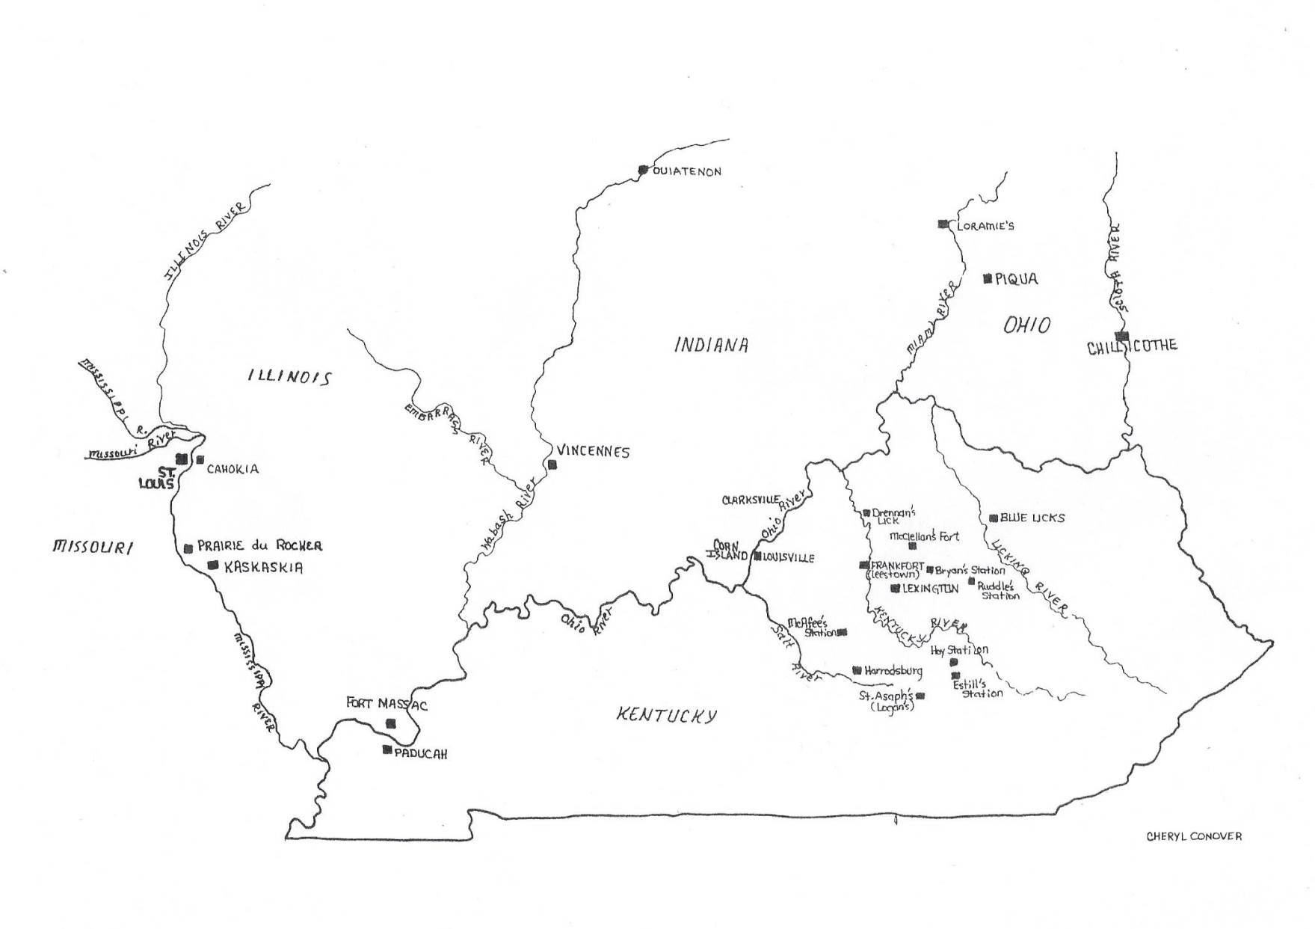*Above: Map of Kentucky and the western frontier during the Revolutionary War. Lincoln County is the area where Harrodsburg, St. Asaph’s (Logan’s Station), Estill’s Station and Hay Station are located. This is the area where James Whitehouse lived in 1782 and served in the Lincoln County Militia.*

They intended to stop at Limestone where Simon Kenton had one of his stations but found signs that Indians had camped there recently. They continued till they reached the Kentucky River where they split into two groups. Kenton took some of the party with him on horseback and they made their way across country to his station at Quick’s Run near the Salt River. Kenton took some of the party with him on horseback and they made their way across country to his station at Quick’s Run near the Salt River. The rest of the group turned inland and continued by boat till they neared Quick’s Run. They dismantled the boat and transported the lumber and their supplies overland to Quick’s Run. Simon Kenton and his group arrived first and were there to greet the river group. Simon took the settlers to the land he had selected to give them and helped the group build additional cabins for the winter. In January, Simon left the group to return to his station near Limestone.

From this brief history it is apparent that James Whitehouse had several opportunities to meet Simon Kenton before he returned to Fauquier County and joined Kenton’s expedition by flatboat down the Ohio River. He may also have come in contact with Benjamin Logan, the overall commander of the Lincoln County Militia, George Rogers Clark, the overall commander of the forces on the western frontier, Daniel Boone Lt. Colonel and second in command of the Fayette County Militia where James filed a land claim, and James Harrod the founder of Harrodsburg near where James settled in 1783. The population of Kentucky grew steadily after James Whitehouse arrived and became a state in 1792.